**A Guide to data searching & Processing**

The goal of this guide is to illustrate how to use the LSEG Workspace and its Excel add-in to identify cooperate bonds and CDS with ESG data and to obtain their prices and spreads as well as control data. Detailed instructions are provided below.

* **Equities:**

1. Open LSEG Workspace and locate the **Search Tools** header. Click **Equity Screener** or choose **Equities** under **Companies, Equities and Funds**.
2. Apply these filters:
   * + PRESENT → Primary Quotes Only and Primary Issues Only (leave Active Only unticked—checking it does not affect the result, but it should remain unchecked).
     + ESG Score ≥ 0.

图形用户界面, 文本

AI 生成的内容可能不正确。These settings return the list of firms with available ESG data.

1. Download the list by clicking the green **Excel** icon in the upper-right corner. 图形用户界面

   AI 生成的内容可能不正确。

截图里有图片

AI 生成的内容可能不正确。Select **Export All** and set the limit to **10,000 rows**.

**Note:** Workspace allows a maximum of 10,000 rows per export. To stay within this limit, apply extra filters so each batch contains fewer than 10,000 firms, export each batch separately, and then combine the files. The quickest approach is to split the universe by issue dates, for example, export firms with issue dates on or before 31/12/2021, then those after 31/12/2021, and so on.

1. 图形用户界面, 应用程序, 表格, Excel

   AI 生成的内容可能不正确。By this step you get all the list in the excel file like the figure below:

Select the column of the ISINs, copy it to another sheet for data processing.

1. 图示

   AI 生成的内容可能不正确。Use the **Datastream Formula** under Workspace (LSEG excel add-in) to obtain data easily.

The complete user guide can be found in the OneDrive folder **Guide for LSEG.** The Datastream formula I employ is outlined below.电脑萤幕的截图

AI 生成的内容可能不正确。

**Some Notes：**

* Series – Paste all ISINs copied from the company list.
* Symbology – Select Datastream when using ISINs; otherwise, choose RIC.
* Datatype – P (Price), the required variable.
* Start / End – Specify the desired date range. From my experience, to reduce download errors, pull data in smaller blocks (e.g., 2025; 2022–24; 2019–21) and merge the files afterward, as LSEG can struggle with very large extracts.
* Options – Tick the boxes shown in the preceding screenshot.
* Date Format – Leave all boxes unchecked.

Put the formula in the first box of the excel, wait for a moment, then you can get the data you need. Copy the whole sheet, paste it to another sheet only with value to obtain the data.

1. Combine the exported Excel files into a single workbook, merging the data by date.

* **One addition notes on equities:**

When you download an updated ISIN list, certain old ISINs may drop off because the equities have been delisted and no longer carry emissions data or an ESG score. These historical records are still valuable, so you should compare the old and new ISIN sets, identify any codes that are missing, and retrieve their prices using the steps above, provided LSEG still retains them in its database.

* **Bonds:**

1. Open LSEG Workspace and locate the **Search Tools** header. Click **Government and Coporate Bonds** under **Fixed Income**.
2. 屏幕的截图

   AI 生成的内容可能不正确。Execute The following filter to obtain the firm list and to download it, also by split the issue dates. Then you obtain the list of the bonds.

**Some Notes:**

* **Preferred RIC:** Contains ‘=’ to ensure each bond has a RIC so the data can be downloaded from Refinitiv Workspace.
* **ESG score**: Confirms that the issuer meets our ESG criteria.
* **Coupon**: Download bonds with coupons > 0 and coupons = 0 separately and chart them in different tabs: zero-coupon bonds are mostly issued by private banks with ESG scores, whereas coupon-bearing bonds cover all issuer types.
* **Issue date**: I filter for issues on or before 30/06/2024 to ensure at least one year of data per bond and to keep the result set manageable significantly

reducing the list of the bonds.

1. Download the bonds with its spread (code **SP**) and its price (code **CMPM**) respectively follow the same excel add-in formula with equities.
2. I will explain below how I process the raw bond data to consolidate everything into a single file together with the corresponding asset details.

* **1.Combine files** – As we do for equities, we bring the assets from each file into a single workbook and merge the data year by year.
* **2.Identify rows that contain data in LSEG** – To exclude assets that appear in the list but have no data in LSEG, we insert a new column in front of the list, name it “withdata”, enter the formula below in cell A2, and copy it down the column:

=IF(SUMPRODUCT(--ISNUMBER(F2:IKL2))>0,"√","")

The formula places a ✓ in the column whenever at least one numeric value exists anywhere in our period; otherwise the cell is left blank.

* **3. Fill in missing identifiers:** Some bonds no longer display a value for the most recent year (2025) because they have matured or the download failed, even though historical data still exist; to ensure these rows remain on the asset list, first filter the withdata column (column A) for the **√** symbol, then in the newest-date column on the far right (currently column F) filter for **no data available** The rows that remain are the bonds missing codes and names in 2025, and for each of these you should manually enter all missing fields (Name, Code, and Currency) after which the data set is complete.

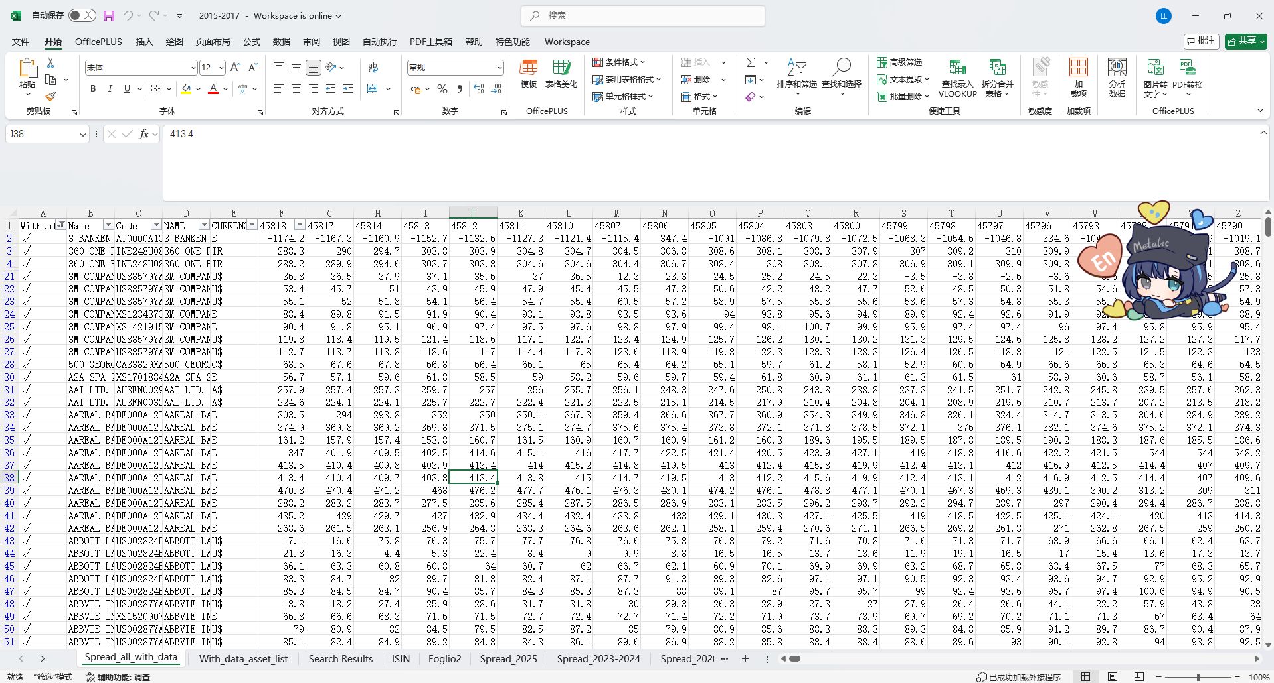After this step the sheet should look like the graph below.

* **4. Get the asset list:** Copy the Code column into the first column of a new sheet and, in cell A2, enter:

=TEXTBEFORE(A2,"(")

Because the original download adds “(SP)” after the ISIN, so this formula extracts the true ISIN or RIC. then obtain each asset’s details with a VLOOKUP function, e.g., in cell B3 enter:

=VLOOKUP(B2,'Search Results'!A2:AJ10000,2,FALSE)

表格

AI 生成的内容可能不正确。and fill the formula down to produce the complete asset details for every code. It should be like the graph below:

* **5. Merge the processed files:** After completing the above steps for each individual year, consolidate all yearly datasets into a single workbook so that every processed file, organized by year.

I did this process on corporate bonds that have coupons larger than zero, equals to zero, and on sovereign bonds.

* **Addition Notes on Bonds:**

Below are the explanations from LSEG that show how to calculate the variables.

* + Spreads:

[SP](https://emea1-datastream.platform.refinitiv.com/navigator/search.aspx?dsid=ZYQL041&host=Dfo&SymbolPref=undefined&multiSelect=true&dt=true&nova=true&l=zh-Hans-CN&version=4.26.1.9&dforic=true&q=SP&prev=dtx1%7C0001_0001_0002&subset=dtx1%7C0001_0001_0001) - G-Spread (over Government Benchmark Curve)

|  |  |
| --- | --- |
|  | |
|  | |
| **Notes** | To calculate datatype SP the maturity ([datatype LF](https://product.datastream.com/WebHelp/Navigator/DatatypeDefinitions/en/13/lf.htm)) and yield ([datatype RY](https://product.datastream.com/WebHelp/Navigator/DatatypeDefinitions/en/13/ry.htm)) of a bond is compared with the equivalent government benchmark bond for the bond’s currency of denomination. The spread is expressed as yield difference (bond minus benchmark) in basis points.  Because the maturities for most of the bonds for which the spread is calculated will not exactly match the maturity of the available government benchmark bonds, linear interpolation is used to estimate the yield of a government benchmark with the same maturity as the bond which is analysed ([datatype EBRY](https://product.datastream.com/WebHelp/Navigator/DatatypeDefinitions/en/13/EBRY.htm)). For bonds with a maturity longer than the longest benchmark, the yield is compared to the longest benchmark and not extrapolated. Similarly, bonds with maturities shorter than the shortest benchmark are compared to the shortest available benchmark.  [Click here for an example spread calculation.](https://product.datastream.com/WebHelp/Navigator/DatatypeDefinitions/en/13/SP_Example.htm) |

* + Prices(Composite MID)：

文本

AI 生成的内容可能不正确。

* **Addition Notes on CDS:**

The procedure for downloading CDS data is the same as for bonds, so the detailed steps are omitted in this part. However, three important points should be noted:

1. After downloading the CDS list, you will obtain only the RICs (Reuters Instrument Codes) of the CDS, not the ISINs of the bonds. You should therefore use these RICs as symbols to download the required variables.
2. Only spread data is available for the time series; LSEG does not provide price data for CDS. Consequently, you can only retrieve spread data.
3. When downloading the list, you cannot filter in LSEG Workspace to determine whether a company issuing the CDS has ESG data. Thus, you should use the following formulas:

First, use the following formula to get the underlying equity ISIN,

=@DSGRID(B4,"CDSEQI","Latest Value","","","Sym=RIC")

Then, use the following formula to ensure that it has an ESG score:

=@DSGRID(D4,"TRESGS","Latest Value","","","Sym=ISIN")

After that we can filter the CDS that have available underlying equity ISINs and corresponding ESG data（ESG score>0）, which allows us to carry out further analysis.

All other steps are identical to the bond procedure.

* **Control data with Bonds and CDS accessible from LSEG:**

The control data and ESG-related data used in previous paper (Campiglio et al., 2025) are as follows:

|  |  |  |  |
| --- | --- | --- | --- |
| Control | | ESG | |
| Code | NAME | Code | NAME |
| WC06011 | Industry Group | ENERDP123 | Estimated CO2 Equivalents Emission Total |
| GGISN | Country Of ISIN Issuer | ENERO03V | Total CO2 Equivalent Emissions To Revenues USD in millions |
| WC02999 | Total Assets | ENERDP096 | CO2 Equivalent Emissions Indirect, Scope 3 |
| WC08291 | EBIT/Total Interest Expense Ratio | ENSCORE | Environment Pillar Score |
| WC08326 | Return On Assets | TRESGSOWOS | Workforce Score |
| WC08346 | Tax Rate | TRESGENERS | Emissions Score |
| WC01001 | Net Sales Or Revenues | ENERDP0161 | Targets Emissions |
| WC08001 | Market Capitalization | TRESGS | ESG Score |
| WC07011 | Employees | ENERDP024 | CO2 Equivalent Emissions Direct, Scope 1 |
| WC08311 | Cash Flow/Sales | ENERDP023 | CO2 Equivalent Emissions Total |

And other Commodities as follows:

|  |  |
| --- | --- |
| Code | NAME |
| CRUDOIL | Crude Oil-WTI Spot Cushing U$/BBL |
| OILWTIN | Crude Oil WTI Cushing U$/BBL |
| EIAEBRT | Europe Brent Spot FOB U$/BBL Daily |
| CRUDBFO | BFO Europe FOB |
| BFO1MEU | Crude Oil BFO M1 Europe FOB $/Bbl |
| NATGAS1 | NYMEX Natural Gas Henry Hub C1 |
| EIATXPR | Mont Belvieu TX Prop Spt FOB U$/GAL |
| PROUSMB | Propane Mont Belvieu Del. Pipe UC/GAL |
| U:SPH | SUBURBAN PROPANE PTNS. |
| PROPANE | Propane, Mt.Belvieu Cents/Gallon |
| PRONUVM | Propane C3 Mont Belvieu U$/Gal |
| PROCMED | Propane CIF MED Del. Term. U$/MT |

For commodities, it is simple: just use the codes to download daily data by Datastream as the previous procedure shows you.

For the other control and ESG data for the bonds, note that these items fall under the datatype “Equities,” whereas bonds and CDS do not share this datatype. Therefore, you should follow the procedure below to obtain the control data separately for bonds and CDS:

1. Before obtaining the data, create a list of equity ISINs that have ESG scores. For the bonds, use the following formulas:

To obtain the Bond Ultimate Parent Company Datastream Equity Code:

=@DSGRID(A3,"BUPCECD","Latest Value","","","Sym=ISIN")

To obtain the corresponding equity ISINs:

=@DSGRID(E2,"ISIN","Latest Value")

After this step, you will have the list of underlying equity ISINs.

For the CDS, since the underlying equity ISINs have already been retrieved, you can use them directly.

1. Download the control and ESG data for each equity ISIN via Datastream, one series at a time.
2. Use a VLOOKUP formula (too lengthy to display here; see the worksheet with the suffix “processed”) to match these obtained data to the bonds’ ISINs and the CDS RICs.

* **Other control data: Market, Size and Value**

`Use the website: <https://jkpfactors.com/factor-returns>. Choose the filters “All countries,” “Daily,” and “Capped Value Weighted (Recommended).” Then, in the Theme/Factor filter, select and download “Market,” “Size,” and “Value” respectively.

You can find the documentation and labels in the folder “mkt&size&value.”